Notes:

# **Meditation**

## The Mind of a Meditator

* Recall: left-to-right ratio in prefrontal cortex (left > right = happier)
  + Buddhist monk had ratio that was literally off the charts!
* **Startle response**: a sudden reflex reaction in response to something potentially threatening
  + More pronounced in those with higher anxiety
  + Buddhist monk Oser showed no startle response!
* Is this realistic? Are the results correlational (do only those who are interested in meditation/have low startle response go on to be monks)? Do we have enough time for this?
* Davidson (2003): participants interested in meditation randomly assigned to 2 groups -- meditation group and wait list (gets rid of uncertainty that results were correlational -- all participants were interested and wanted to meditate)
  + Meditation group meditated for 8 weeks, 45 min/day
  + Results:
    - Decrease in anxiety compared to baseline
    - Increase in mood
    - Stronger immune system
    - Larger ratio of Left/Right PFC activity
    - Causal evidence!
* Mrazek (2013): mindfulness training and GRE performance; randomly assigned to 2 groups -- meditation class and nutrition class, both classes met 4 days per week for two weeks
  + Meditation group meditated 10-20 minutes of meditation during class plus 10 minutes of daily meditation out of class
  + Before and after the class, did reading comprehension passages from GRE, assessed working memory capacity (WMC)
  + 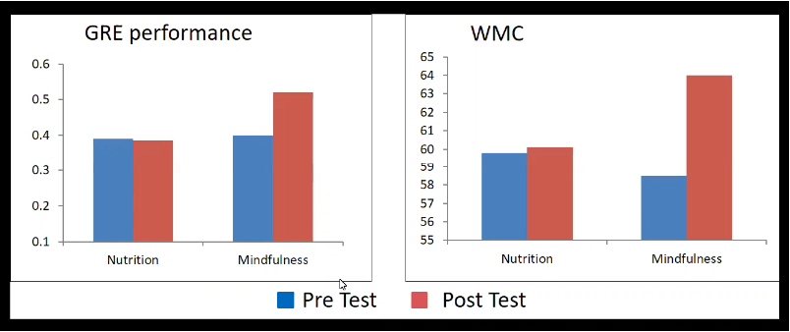

* Mindfulness training strengthens performance on cognitive tasks by *reducing unrelated/distracting thoughts*

## Mindfulness Meditation

* Focus on one thing -- often breathing, counting breaths
* No good or bad meditation
* When the mind wanders and you have to bring it back, that's ok -- in fact, that's the **most important part!!**

## Multitasking

* Garavan (1998): are we capable of attending to two distinct concepts simultaneously -- does multitasking exist?
  + Subjects counted circles and triangles on a screen, shapes presented sequentially, have to keep two running tallies for each shape
  + Reported shape counts at the end of each trial, pressed spacebar to advance to next trial (recorded reaction time)
  + Two trial types: **no switch** (same as previous shape), **switch** (different from previous shape)
    - Switch trials took significantly longer -- multitasking slows you down and increases error!
* Bowman, Levine, Waite, Gendron (2010): students read an article on a computer monitor on a subject they weren't already familiar with, would read 5 pages one at a time, five instant messages appeared on screen as they were reading, followed by test on material
  + Conditions: 1) IM before reading, 2) IM during reading, 3) no IMs actually came
  + Condition 2 took significantly longer to read articles (corrected for time reading and responding to IM)
  + No cost in terms of reading comprehension performance
* Attention:
  + Is a limited resource
  + Functions like a spotlight -- only one thing can be illuminated at a time
  + Can be allocated only to one thing at a time
* Does multitasking exist? NO!
* Place breaks in between different tasks, not in the middle of one (inserts switch cost!)